Modual-1

1. What is software? What is software engineering?

Ans. Software is **a set of instructions, data or programs used to operate computers and execute specific tasks**. It is the opposite of hardware, which describes the physical aspects of a computer. Software is a generic term used to refer to applications, scripts and programs that run on a device.

Software engineering has two parts: software and engineering. Software is **a collection of codes, documents, and triggers that does a specific job and fills a specific requirement**. Engineering is the development of products using best practices, principles, and methods.

1. Explain types of software

Ans. The two main categories of software are [application](https://www.techtarget.com/searchsoftwarequality/definition/application) software and [system software](https://www.techtarget.com/whatis/definition/system-software).

* **Application software.**The most common type of software, application software is a computer software package that performs a specific function for a user, or in some cases, for another application. An application can be self-contained, or it can be a group of programs that run the application for the user.
* **System software.** These software programs are designed to run a computer's application programs and hardware. System software coordinates the activities and functions of the hardware and software.

1. What is SDLC? Explain each phase of SDLC

Ans. The Software Development Life Cycle (SDLC) is **a structured process that enables the production of high-quality, low-cost software, in the shortest possible production time**. The goal of the SDLC is to produce superior software that meets and exceeds all customer expectations and demands.

1) Requirement Gathering

Requirements gathering is the process of identifying your project’s exact requirements from start to finish.

2) Analysis

The analysis phase also gathers business requirements and identifies any potential risks.

3) Design

The design phase is a stage where software developers define the technical details of the product. Depending on the project, these details can include screen designs, database, sketches, system interfaces, and prototypes. Clients use these details to make final product design choices.

4)Implementation

Implementation phase is initiated after the system has been tested and accepted by the user. In this phase, the system is installed to support the intended business functions.

5)Testing

The testing phase of SDLC is where you focus on investigation and discovery. During the testing phase, developers find out whether their code and programming work according to customer requirements.

6)Maintenance

The maintenance phase of the SDLC occurs after the product is in full operation. Maintenance of software can include software upgrades, repairs, and fixes of the software if it breaks. Software applications often need to be upgraded or integrated with new systems the customer deploys

1. What is DFD? Create a DFD diagram on Flipkart

Ans. A data flow diagram (DFD) is **a graphical or visual representation using a standardized set of symbols and notations to describe a business's operations through data movement**.

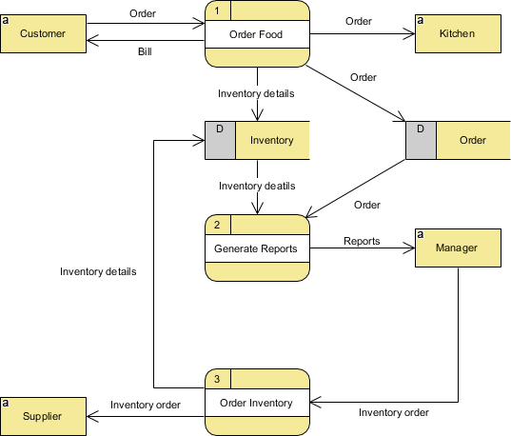

1. What is Flow chart? Create a flowchart to make addition of two numbers

Ans. A flowchart is **a picture of the separate steps of a process in sequential order**. It is a generic tool that can be adapted for a wide variety of purposes, and can be used to describe various processes, such as a manufacturing process, an administrative or service process, or a project plan.

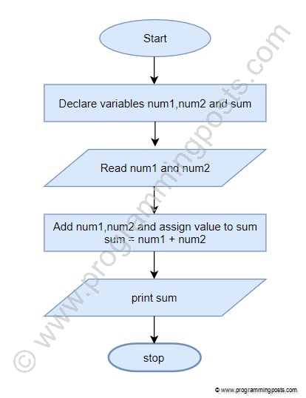

1. What is Use case Diagram? Create a use-case on bill payment on paytm.

Ans. Use-case diagrams **describe the high-level functions and scope of a system**. These diagrams also identify the interactions between the system and its actors. The use cases and actors in use-case diagrams describe what the system does and how the actors use it, but not how the system operates internally.

